**LAB 7**  **BOOK DATABASE**

CREATE TABLE PUBLISHER( NAME VARCHAR(30), ADDRESS VARCHAR(50), PHONE VARCHAR(10), PRIMARY KEY(NAME));

CREATE TABLE BOOK( BOOK_ID INT, TITLE VARCHAR(30), PUBLISHER_NAME VARCHAR(50), PUB_YEAR VARCHAR(30), PRIMARY KEY(BOOK_ID), FOREIGN KEY(PUBLISHER_NAME) REFERENCES PUBLISHER(NAME) ON DELETE CASCADE) ;

CREATE TABLE BOOK_AUTHORS( BOOK_ID INT, AUTHOR_NAME VARCHAR(30), PRIMARY KEY(BOOK_ID,AUTHOR_NAME), FOREIGN KEY(BOOK_ID) REFERENCES BOOK(BOOK_ID) ON DELETE CASCADE);

CREATE TABLE LIBRARY_BRANCH( BRANCH_ID INT, BRANCH_NAME VARCHAR(30), ADDRESS VARCHAR(50), PRIMARY KEY(BRANCH_ID));

CREATE TABLE BOOK_COPIES( BOOK_ID INT, BRANCH_ID INT, COPIES INT, PRIMARY KEY(BOOK_ID,BRANCH_ID), FOREIGN KEY(BOOK_ID)REFERENCES BOOK(BOOK_ID) ON DELETE CASCADE , FOREIGN KEY(BRANCH_ID)REFERENCES LIBRARY_BRANCH(BRANCH_ID) ON DELETE CASCADE);

CREATE TABLE CARD( CARD_NO INT, PRIMARY KEY(CARD_NO));

CREATE TABLE BOOK_LENDING( BOOK_ID INT, BRANCH_ID INT, CARD_NO INT, DATE_OUT DATE, DUE_DATE DATE, PRIMARY KEY(BOOK_ID,BRANCH_ID,CARD_NO), FOREIGN KEY(BOOK_ID) REFERENCES BOOK(BOOK_ID) ON DELETE CASCADE, FOREIGN KEY(BRANCH_ID) REFERENCES LIBRARY_BRANCH(BRANCH_ID) ON DELETE CASCADE, FOREIGN KEY(CARD_NO) REFERENCES CARD(CARD_NO) ON DELETE CASCADE);

INSERT INTO PUBLISHER VALUES ('MCGRAW-HILL','9989076587','BANGALORE');

INSERT INTO PUBLISHER VALUES ('PEARSON', '9889076565', 'NEW DELHI');

INSERT INTO PUBLISHER VALUES ('RANDOM HOUSE', '7455679345', 'HYDERABAD');

INSERT INTO PUBLISHER VALUES ('HACHETTE LIVRE', '8970862340', 'CHENNAI');

INSERT INTO PUBLISHER VALUES ('GRUPO PLANETA','7756120238', 'BANGALORE');

INSERT INTO BOOK VALUES ('1','DBMS', 'MCGRAW-HILL','JAN-2017');

INSERT INTO BOOK VALUES ('2','ADBMS', 'MCGRAW-HILL','JUN-2016');

INSERT INTO BOOK VALUES ('3','CN', 'PEARSON','SEP-2016');

INSERT INTO BOOK VALUES ('4','CG', 'GRUPO PLANETA','SEP-2015');

INSERT INTO BOOK VALUES ('5','OS', 'PEARSON','MAY-2016');

INSERT INTO BOOK_AUTHORS VALUES ('1','NAVATHE');

INSERT INTO BOOK_AUTHORS VALUES ( '2','NAVATHE');

INSERT INTO BOOK_AUTHORS VALUES ( '3','TANENBAUM');

INSERT INTO BOOK_AUTHORS VALUES ('4','EDWARD ANGEL');

INSERT INTO BOOK_AUTHORS VALUES ('5','GALVIN');

INSERT INTO LIBRARY_BRANCH VALUES ('10','RR NAGAR','BANGALORE');

INSERT INTO LIBRARY_BRANCH VALUES ('11','RNSIT','BANGALORE');

INSERT INTO LIBRARY_BRANCH VALUES ('12','RAJAJI NAGAR','BANGALORE');

INSERT INTO LIBRARY_BRANCH VALUES ('13','NITTE','MANGALORE');

INSERT INTO LIBRARY_BRANCH VALUES ('14','MANIPAL','UDUPI');

INSERT INTO BOOK_COPIES VALUES ( 1, 10,10);

INSERT INTO BOOK_COPIES VALUES ( 1, 11,5);

INSERT INTO BOOK_COPIES VALUES ( 2, 12,2);

INSERT INTO BOOK_COPIES VALUES ( 2, 13,5);

INSERT INTO BOOK_COPIES VALUES ( 3, 14,7);

INSERT INTO BOOK_COPIES VALUES ( 5, 10,1);

INSERT INTO BOOK_COPIES VALUES ( 4, 11,3);

INSERT INTO CARD VALUES (100);

INSERT INTO CARD VALUES (101);

INSERT INTO CARD VALUES (102);

INSERT INTO CARD VALUES (103);

INSERT INTO CARD VALUES (104);

INSERT INTO BOOK_LENDING VALUES ( 1, 10, 101,'01-JAN-17','01-JUN-17');

INSERT INTO BOOK_LENDING VALUES ( 3, 14, 101,'11-JAN-17','11-MAR-17');

INSERT INTO BOOK_LENDING VALUES ( 2, 13, 101,'21-FEB-17','21-APR-17');

INSERT INTO BOOK_LENDING VALUES ( 4, 11, 101,'15-MAR-17','15-JUL-17');

INSERT INTO BOOK_LENDING VALUES ( 1, 11, 104,'12-APR-17','12-MAY-17');

SELECT * FROM PUBLISHER;

SELECT * FROM BOOK;

SELECT * FROM LIBRARY_BRANCH;

SELECT * FROM BOOK_COPIES;

SELECT * FROM CARD;

SELECT * FROM BOOK_LENDING;

SELECT B.BOOK_ID, B.TITLE, B.PUBLISHER_NAME, A.AUTHOR_NAME, C.COPIES, L.BRANCH_ID FROM BOOK B, BOOK_AUTHORS A, BOOK_COPIES C, LIBRARY_BRANCH L WHERE B.BOOK_ID=A.BOOK_ID AND B.BOOK_ID=C.BOOK_ID AND L.BRANCH_ID=C.BRANCH_ID;

SELECT CARD_NO FROM BOOK_LENDING WHERE DATE_OUT BETWEEN '01-JAN-2017' AND '01-JUL-2017' GROUP BY CARD_NO HAVING COUNT (*)>3;

DELETE FROM BOOK WHERE BOOK_ID=3;

CREATE VIEW V_PUBLICATION AS SELECT PUB_YEAR FROM BOOK;

SELECT * FROM V_PUBLICATION;

CREATE VIEW V_BOOKS AS SELECT B.BOOK_ID, B.TITLE, C.COPIES FROM BOOK B, BOOK_COPIES C, LIBRARY_BRANCH L WHERE B.BOOK_ID=C.BOOK_ID AND C.BRANCH_ID=L.BRANCH_ID;

SELECT * FROM V_BOOKS;

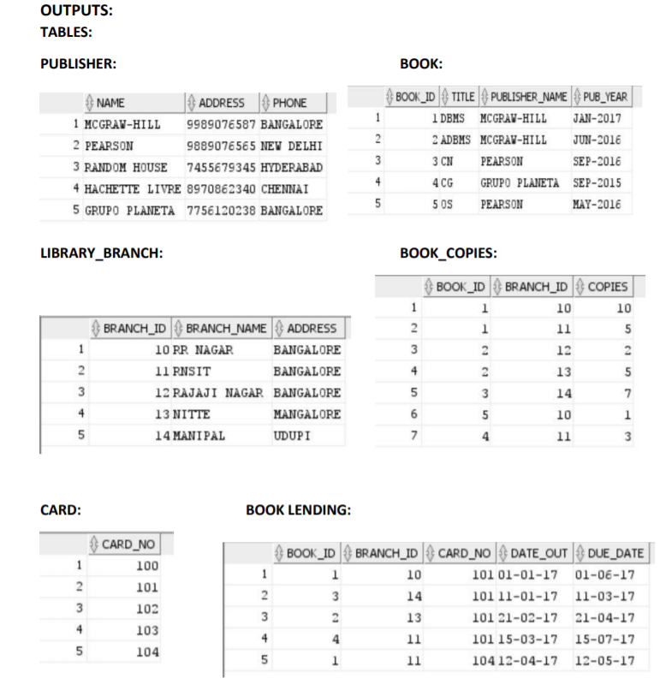

**OUTPUT**

